Sudden Unexpected Death in Infancy:
An analysis of coronial SUDI Liaison Reports from Sept 2018 to June 2020 with subsequent recommendations
2022

Acknowledgements
Ministry of Health
Barry Taylor and Anna Foaese
The work described in this report was undertaken by Professor Barry Taylor and Anna Foaese during 2020 and was completed in June 2021.
Professor Barry Taylor was on sabbatical from the University of Otago during 2020 and was a principal advisor on child health over this time. Anna Foaese was a practicing midwife and portfolio manager over the same period.

DRAFT – not government policy
Citation: Ministry of Health. 2022. Sudden Unexpected Death in Infancy: An analysis of coronial SUDI Liaison Reports from Sept 2018 to June 2020 with subsequent recommendations. Wellington: Ministry of Health.
Published in May 2022 by the Ministry of Health
PO Box 5013, Wellington 6140, New Zealand
ISBN 978-1-99-110051-1 (online)
HP 8181
This document is available at health.govt.nz
This work is licensed under the Creative Commons Attribution 4.0 International licence. In essence, you are free to: share ie, copy and redistribute the material in any medium or format; adapt ie, remix, transform and build upon the material. You must give appropriate credit, provide a link to the licence and indicate if changes were made.

Contents
Introduction 1
Method 2
Background 4
Post-neonatal mortality 4
SUDI and the International Classification of Diseases – 10 (ICD-10) 5
Results 9
Demographic and quantitative data 9
Specific SUDI risk factors identified in the SUDI liaison interview 13
Caveat 16
Thematic analysis 16
Summary 21
Recommendations 22
References 29
Appendix 1: SUDI liaison form v2.1 30
SUDI Liaison Report 30
Appendix 2: Causal pathways to SUDI risk factors and preventing SUDI 58

List of Figures
Figure 1: Neonatal and post-neonatal infant mortality in Aotearoa New Zealand, 1931–2017 4
Figure 2: Māori versus non-Māori post-neonatal infant mortality in Aotearoa New Zealand, 1970–2016 5
Figure 3: Māori versus non-Māori SIDS/SUDI rates in Aotearoa New Zealand, 1978–2016 6
Figure 4: Post-perinatal infant (7–364 days) mortality in Aotearoa New Zealand, by ethnicity, 2002–2020 7
Figure 5: Provisional SUDI liaison reports for Aotearoa New Zealand, by month of death, Sept 2018–June 2020 9
Figure 6: Age of mothers of SUDI death infants in Aotearoa New Zealand, 16–41 years, Sept 2018–June 2020 10
Figure 7: Age of infant at time of death in Aotearoa New Zealand (provisional SUDI liaison reports), 0–52 weeks, Sept 2018–June 2020 10
Figure 8: Gestation at birth in Aotearoa New Zealand (provisional SUDI liaison reports), 27–42 weeks, Sept 2018–June 2020 11
Figure 9: Financial security status of whānau/families in Aotearoa New Zealand (provisional SUDI liaison reports), Sept 2018–June 2020 11
Figure 10: Ethnicity of live-born infants in Aotearoa New Zealand (provisional SUDI liaison reports), Sept 2018–June 2020 12
Figure 11: DHB of residence (provisional SUDI liaison reports), Sept 2018–June 2020 12
Figure 12: Smoking in pregnancy rates in Aotearoa New Zealand (provisional SUDI liaison reports), Sept 2018–June 2020 13
Figure 13: Position placed to sleep for SUDI infants in Aotearoa New Zealand (provisional SUDI liaison reports), Sept 2018–June 2020 14
Figure 14: Position found for SUDI infants in Aotearoa New Zealand (provisional SUDI liaison reports), Sept 2018–June 2020 15
Figure 15: Place of sleep for SUDI infants in Aotearoa New Zealand (provisional SUDI liaison reports), Sept 2018–June 2020 15

List of Tables
Table 1: Provisional SUDI deaths pending coroner's official finding, for the year 1 JULY 2019–30 June 2020 8

Introduction
Sudden unexplained death in infancy (SUDI) is the collective term used to describe any unexpected death of an infant (a child under one-year-old) – with neither the parents nor health professionals having any expectation of it happening. It is a broader term than sudden infant death syndrome (SIDS, often previously known as ‘cot death’), which is defined as an infant death where an on-site investigation and a post-mortem, does not identify a cause of death. SUDI therefore includes infant deaths where coroners’ pathologists declare the death ‘unascertained’, as well as deaths in circumstances of high risk, such as when the infant is found face down into soft bedding or dies during bed sharing.

The Ministry of Health (Ministry) codes the cause of death using ICD10 codes and reports it in the annual fetal and infant deaths report. It can take up to three years for the Ministry to make the final classification of the cause of death, using all the information available (including the results of any post-mortem examination and findings from the coronial investigation). Thus, the official statistics for infants dying in 2016 deaths were only reported in November 2019, impacting on the speed with which programmes aimed at preventing SUDI can be evaluated for their effectiveness.

This report sets out the background and findings from analysis of 64 infant deaths between Sept 2018 and 30 June 2020.

Method
In the absence of official statistics, the researchers of this report, Dr Barry Taylor (paediatrician, academic and a Principal Advisor to the Ministry of Health) and Anna Foaese (midwife and Senior Portfolio Manager at the Ministry of Health), selected provisional SUDI numbers and coronial SUDI liaison reports (liaison reports) as the best sources of information to inform a review of programme effectiveness.

The liaison reports document information gathered directly from whānau/families. A health-trained coronial investigator interviewed parents and whānau/families of infants who have died, usually within two to three weeks of the death. A standardised interview format was used (see Appendix 1: SUDI liaison form v2.1), and whānau/families were asked to use a mannequin to show the position the infant had been placed in and was subsequently found.

The researchers analysed the data from the SUDI liaison reports, which are available in a restricted access folder within the Ministry’s secure filing system. An initial review of several reports underpinned the selection of elements to be extracted to inform the analysis. The elements selected include:
- demographic data (age of infant, district health board of birth, gender, ethnicity, maternal and paternal ages)
- gestation at birth and birth weight
- social and behavioural risk factors for SUDI (maternal smoking during pregnancy, maternal and paternal alcohol and other drug use around time of death)
- infant’s sleep position placed and found, face clear when found
- sleep sack use
- dummy use, breast feeding ever and at time of death
- sleep surface (type of bed).

The reviewers also extracted from the reports information on:
- recall of safe sleep messages that the whānau/families received (and from whom)
- smoking cessation advice provided and any uptake of that advice
- financial security as determined by the whānau/families
- any clinical review by a health professional in the two weeks before the death and the reason for the review.

The researchers recorded the whānau/family story of events leading up to the death in a narrative style. From the narratives and other information, the reviewers extracted notable elements, with up to four comments on key issues per case. Thus, eight comment fields were available for qualitative analysis.

The reviewers recorded coded data in an Excel spreadsheet and, for quantitative elements, they checked each others’ work for agreement. Discrepancies were resolved by going back to the original liaison reports. Comments were left intact and used for the qualitative analysis.

The reviewers used Excel pivot tables and graphs to extract descriptive data.

Background

Historical rates

Infant mortality (deaths in the first year of life) is often divided into neonatal (the first month of life) and post-neonatal mortality (1 month to 1 year of age). Figure 1 sets the historical picture of these two rates since reliable records were kept in New Zealand from the early 1930s.
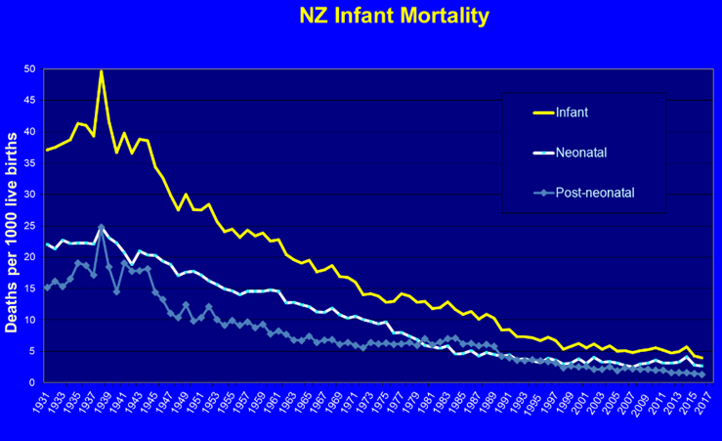
Figure 1: Neonatal and post-neonatal infant mortality in Aotearoa New Zealand, 1931–2017

Post-neonatal mortality
Figure 2 shows the large differences in post-neonatal mortality between Māori and non-Māori since ethnicity was first documented in 1970. The gap in data from 1995 to 1996 is the result of the change from coding ethnicity classified by ancestry to self-identified ethnicity. In most years, between 50 and 60% of post-neonatal mortality has been labelled SUDI.

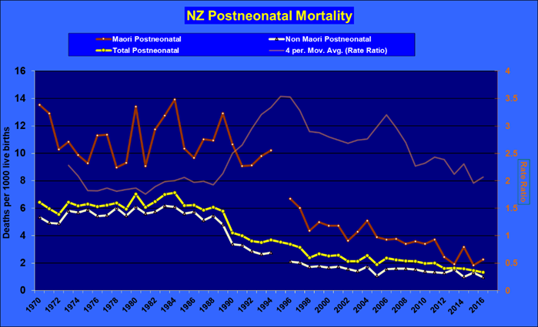
Figure 2: Māori versus non-Māori post-neonatal infant mortality in Aotearoa New Zealand, 1970–2016

SUDI and the International Classification of Diseases – 10 (ICD-10)
Official statistics on SUDI are available from 2006 by combining deaths with the following ICD-10 codes recorded as the underlying cause of death: R95 (sudden infant death syndrome), R96 (other sudden death, cause unknown), R98 (unattended death), R99 (other ill-defined and unspecified causes of mortality), W75 (accidental suffocation and strangulation in bed), W78 (inhalation of gastric contents) and W79 (inhalation and ingestion of food causing obstruction of respiratory tract). This coding has also allowed international comparison (Taylor BJ et al 2015).

SIDS/SUDI rate and risk factors
The very high rates of SIDS in the 1980s (approximately 200–250 deaths per year; see Figure 3) led to the New Zealand Cot Death Study (Scragg et al 1993; Mitchell et al 1993, 1992a, b, c, d, 1991; Taylor 1991), which identified key SIDS risk and protective factors as being:
- infants sleeping on their front (prone)
- mothers smoking in pregnancy
- co-sleeping (often called bed sharing)
- a protective effect from breast feeding.

Subsequent analysis showed that risk was increased with side sleeping as well as prone and a multiplicative and very high risk of death from the combination of maternal smoking in pregnancy and co-sleeping with infant after birth (Scragg et al 1993). A New Zealand case control study from 2012 to 2015 showed that the risk of death is 33 times higher where these two risk factors are present than where they are not (Mitchell EA et al 2017).
Figure 3: Māori versus non-Māori SIDS/SUDI rates in Aotearoa New Zealand, 1978–2016
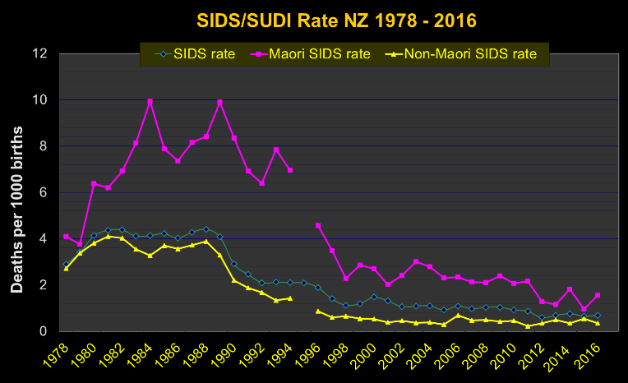

Sleep placement
There was an immediate drop in SIDS/SUDI rates throughout most of the 1990s (see Figure 3). This decline has been attributed to the recommended change in infant sleeping position, with the move to placing infants on their backs for sleeping. This change was rapidly adopted in Aotearoa New Zealand across all ethnic groups (Mitchell et al 1997). However, the SIDS rate reduction for Māori was not evident until approximately five years after the initial reduction for non-Māori infants.

Smoking and co-sleeping
Higher rates of maternal smoking in Māori women combined with co-sleeping habits have been the main explanations attributed to these inequitable SIDS reduction rates. In response to the New Zealand Cot Death Study (Scragg et al, 1993) findings, Dr David Tipene-Leach and Stephanie Cowan independently developed protective interventions to provide a safe sleeping space for infants when parents preferred to co-sleep. These were respectively the wahakura, a bassinet-shaped flax basket, woven using traditional methods; and the Pēpi-Pod®, a shallow plastic box with bedding designed and provided specifically to fit (Tipene-Leach and Abel 2010; Cowan et al 2013). These infant safe-sleep beds have increasingly been offered to whānau/families of infants where the mother smoked in pregnancy and who intend to co-sleep.

National SUDI Prevention Programme
Since July 2017, the Ministry has funded a national programme to coordinate delivery of safe sleep messages to all new parents and their whānau/families and to deliver safer sleep spaces to approximately 15% of higher risk newborn (up to four-weeks-old) infants. However, there has been no significant improvement in SUDI rates since 2012. In fact, recently, official post-neonatal statistics suggest a significant increase in rates – especially for Māori pēpi.

Coronial process
The Ministry publishes the official figures of SUDI deaths once full coronial enquires have been completed. These figures are based on date of death, regardless of the length of investigation, which may take two to three years to complete. Infant death data are available in close to real time through the Stats NZ quarterly mortality figures, which identify the ethnicity of the infants who died but not the causes of death.

Post-perinatal mortality by ethnicity
In Figure 4, the purple line (all ethnicities) suggests that, since 2017, there has been a slight overall increase in deaths in Aotearoa New Zealand for infants aged 7–364 days. The same figure shows that the death rates in non-Māori and other ethnic groups have remained relatively static. The death rate for Pacific infants has remained higher than those for the non-Māori and Other ethnicities since 2002; although lower than for Māori. There appears to be a large increase in Māori infant deaths for this age group in the last two years.
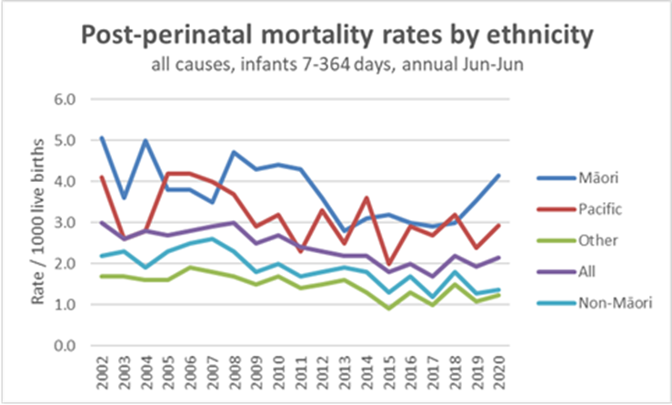
Figure 4: Post-perinatal infant (7–364 days) mortality in Aotearoa New Zealand, by ethnicity, 2002–2020

Following all coronial investigations, it is expected that of all the deaths in this age group, approximately 40–50% will end up being classified as SUDI. The data shown in Figure 4 suggest the possibility of an increase in SUDI rates in the latest three years (from 2017 to 2020). This is reflected in the monthly provisional SUDI cases reported to the Ministry from the coroner’s office. The provisional SUDI numbers will reduce once the full coronial investigation processes, including post-mortem reports, are available. A report from the Child and Youth Mortality Review Committee (CYMRC) suggests they will drop approximately 10% following final coding. The most recent available of these provisional figures are shown in Table 1 below.
Table 1: Provisional SUDI deaths pending coroner's official finding, for the year 1 JULY 2019–30 June 2020
Ethnicity | Total number of provisional SUDI deaths | Estimated births | Estimated provisional SUDI rate per 1,000 births
Māori | 44 | 17,521 | 2.51
Pacific peoples | 10 | 6,091 | 1.64
NZ European | 7 | 25,112 | 0.28
Asian | 4 | 10,688 | 0.37
Other |  | 1,460 | 0.00
Total NZ | 65 | 60,872 | 1.07

Overall, there has been no decrease in the SUDI rates over the last four years. Aotearoa New Zealand has not achieved the national goal of 0.1 deaths per 1,000 births demonstrated in other Organisation for Economic Co-operation and Development (OECD) countries. Inequities continue to exist for Māori.

Currently Māori pēpi are 8.5 times more likely to die of SUDI than non-Māori non-Pacific infants. The reasons behind this difference need to be understood before more effective interventions can be planned. This investigation of SUDI liaison reports is an initial step in achieving that understanding.

Results

Demographic and quantitative data
SUDI liaison reports were available from late 2018, with the date of death of the first report being 19 September 2018. Sixty-four reports were available for this review up to the end of June 2020. This represents 72% of the 89 infants reported in the same time period to the coroners and initially coded as possible SUDI (Ed Mitchel, personal communication, Dec 2020). Of the 64 SUDI liaison reports analysed, six were finally thought by the coroners’ interim coding to be ‘death from infection’. The monthly numbers are shown in Figure 5.
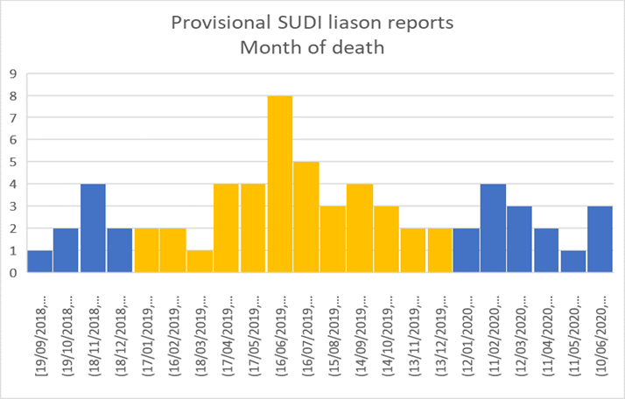
Figure 5: Provisional SUDI liaison reports for Aotearoa New Zealand, by month of death, Sept 2018–June 2020

Maternal age
Figure 6 shows that ten of the 64 mothers were aged under 20 years (12.5%). This is higher than in 2018, when 4% of infants were born to mothers under 20 years of age (Report on Maternity web tool). The largest proportion of mothers were in the 21–25 years age group.
Figure 6: Age of mothers of SUDI death infants in Aotearoa New Zealand, 16–41 years, Sept 2018–June 2020

Infant age and gender
The greatest proportion of SUDI occurred in the infants’ first eight weeks of life (24 out of 64, 39%). Sixty-one percent of the infants were male, similar to most other reported series of SUDI infants.
Figure 7: Age of infant at time of death in Aotearoa New Zealand (provisional SUDI liaison reports), 0–52 weeks, Sept 2018–June 2020

Gestation at birth
As shown in Figure 8, most infants were born at term (38–40 weeks). Gestational age ranged from 27 weeks gestation to 41 weeks. Seventeen percent were born premature compared with 7.5% of infants born premature in the previous year (Report on Maternity web tool).
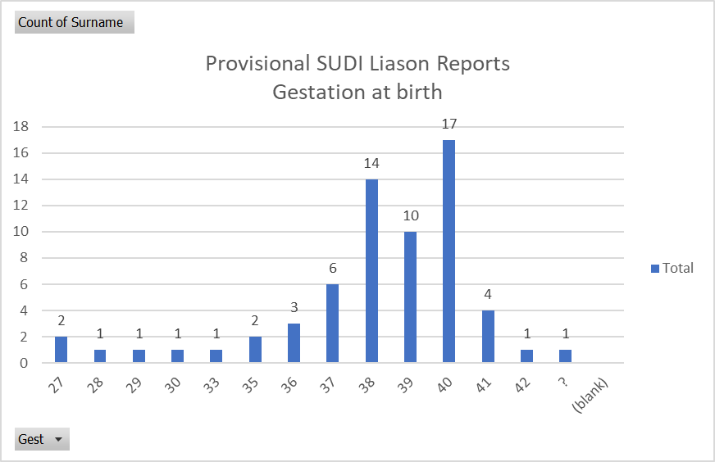
Figure 8: Gestation at birth in Aotearoa New Zealand (provisional SUDI liaison reports), 27–42 weeks, Sept 2018–June 2020

Financial security
For the SUDI liaison reports, whānau/families were asked a question about how they ‘made ends meet’. The answers to this question were coded ‘low’ if the whānau/families were dependant on a benefit and ‘very low’ if they were living without income or benefit. Figure 9 shows that whānau/families that lost infants through SUDI were usually living with considerable financial insecurity (just over half the cases reviewed).
Figure 9: Financial security status of whānau/families in Aotearoa New Zealand (provisional SUDI liaison reports), Sept 2018–June 2020
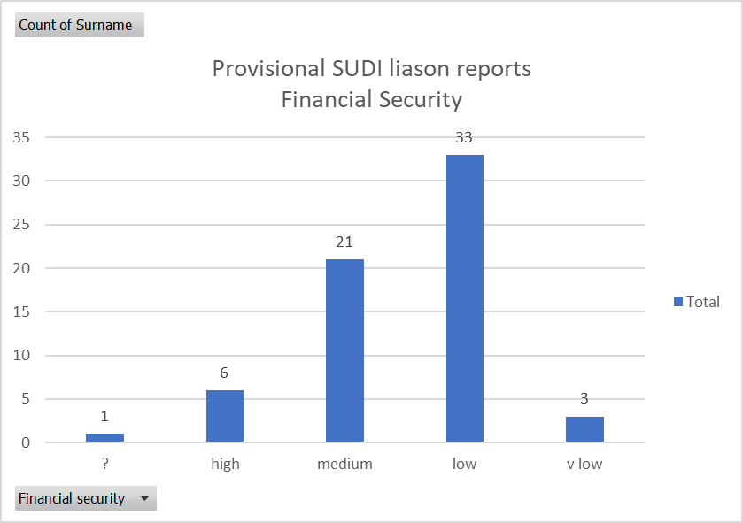

Ethnicity
As Figure 10 shows, the infants’ ethnicity was predominately Māori (65.6%), with 20.3% Pacific peoples. This contrasts to 37.9% of live-born infants being Māori in the previous year.
Figure 10: Ethnicity of live-born infants in Aotearoa New Zealand (provisional SUDI liaison reports), Sept 2018–June 2020
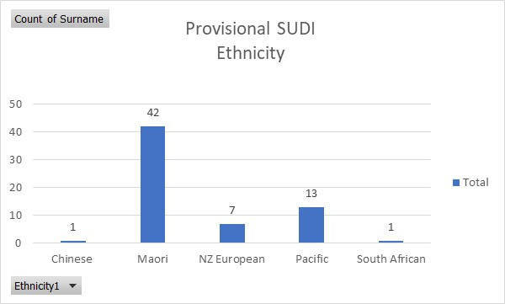

DHB of residence
Figure 11 shows that the highest number of SUDI occurred in Counties Manukau DHB (22), followed by Waikato (9), Canterbury (7) and Bay of Plenty (5) DHBs. Please note that Hawke’s Bay, Taranaki, Whanganui, Nelson Marlborough, South and West Coast DHBs did not provide data for this year.
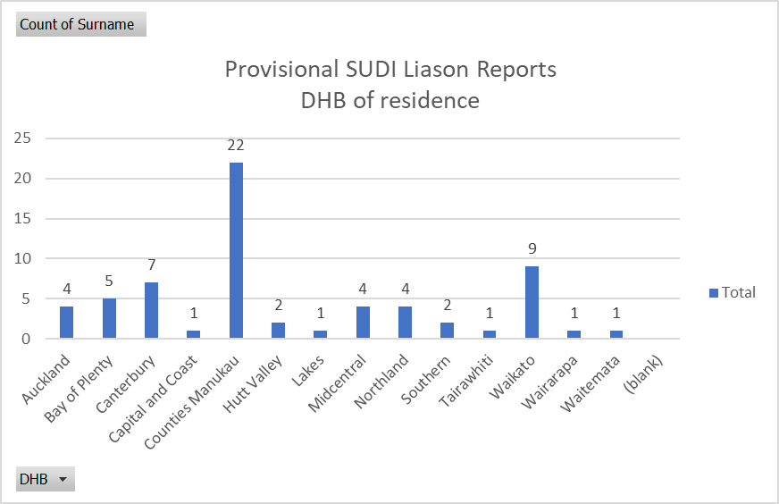
Figure 11: DHB of residence (provisional SUDI liaison reports), Sept 2018–June 2020

Specific SUDI risk factors identified in the SUDI liaison interview
Maternal smoking in pregnancy and drug and alcohol use reported around time of death
Maternal smoking in pregnancy was commonly reported and present in 70% of cases (45 out of the 64 cases, see Figure 12). The latest data on maternal smoking in Aotearoa New Zealand comes from the Well Child Tamariki Ora (WCTO) Quality Improvement Framework indicators from 2019/20. The rate of maternal smoking in this group of SUDI infants appears much higher than in the population as a whole. In the WCTO indicators, Well Child providers nationally classified 41% of homes as ‘not smoke free’ when infants were six weeks old. In the Counties Manukau DHB area, that rate was 49%.

Health services offered smoking cessation support to all smoking mothers of the SUDI infants, however 74% of mothers offered help did not take up cessation support at that time.

In 20% of SUDI cases, alcohol use was reported by caregivers at the time of death.
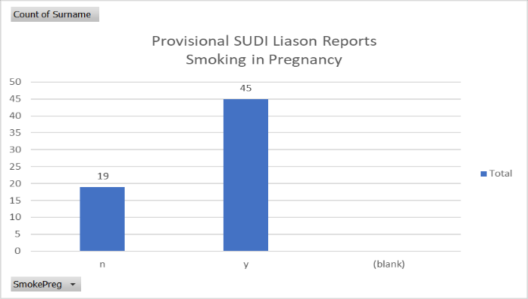
Figure 12: Smoking in pregnancy rates in Aotearoa New Zealand (provisional SUDI liaison reports), Sept 2018–June 2020

Position placed to sleep
As Figure 13Figure 13 shows, 30% of SUDI infants had been placed in an unsafe sleep position (side, 12, or front, 7). National data on this behaviour is not available currently (data is collected in the Whānau Āwhina Plunket electronic record for 80% of Aotearoa New Zealand infants but has not been reported). The most recent case control study in Aotearoa New Zealand reported 16.7% of matched controls as being placed to sleep on side or front (Mitchell et al 2017). From the available data, being placed to sleep prone or on the side remains a significant risk factor that needs continued emphasis in prevention programmes.
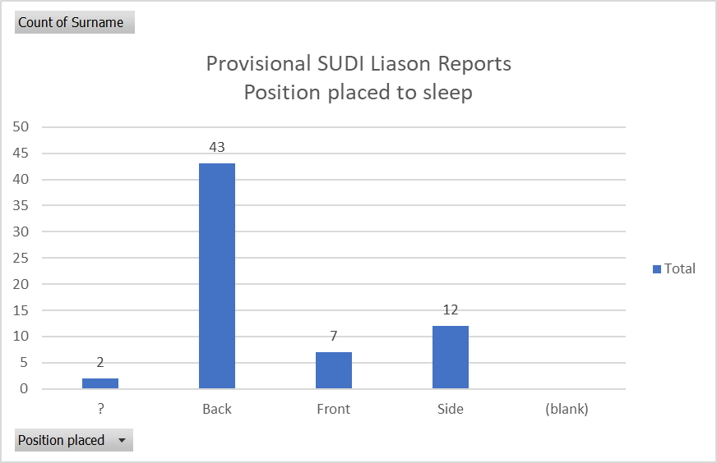
Figure 13: Position placed to sleep for SUDI infants in Aotearoa New Zealand (provisional SUDI liaison reports), Sept 2018–June 2020

Position found
Position found as reported by the caregivers is shown in Figure 14. Twenty-nine infants (45%) were found either on their front (17), side (11) or hanging (1). For six infants, the position found was not described.

Many caregivers were unable to determine whether the face was clear or not. Overall, 53% of SUDI infants did not have their face clear when found. Of those placed on their back (29), approximately half were found with their face clear, whereas none of those placed prone had their face clear and, of those placed on their side, only two of 12 (17%) were found with their face clear.
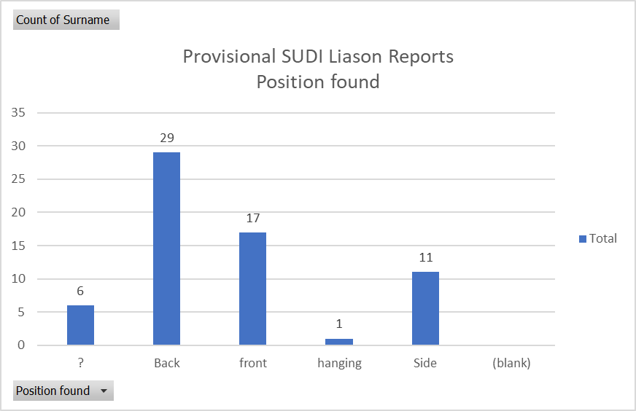
Figure 14: Position found for SUDI infants in Aotearoa New Zealand (provisional SUDI liaison reports), Sept 2018–June 2020

Place of sleep
Forty-four infants (69%) were placed to sleep in an unprotected, potentially dangerous place (adult bed or mattress, couch or armchair) (see Figure 15).

Although there was no direct question in the SUDI liaison report about the availability of a safe sleep place, the written text showed that 67% of cases reported a safe sleep space being available in the house but not used.
Figure 15: Place of sleep for SUDI infants in Aotearoa New Zealand (provisional SUDI liaison reports), Sept 2018–June 2020
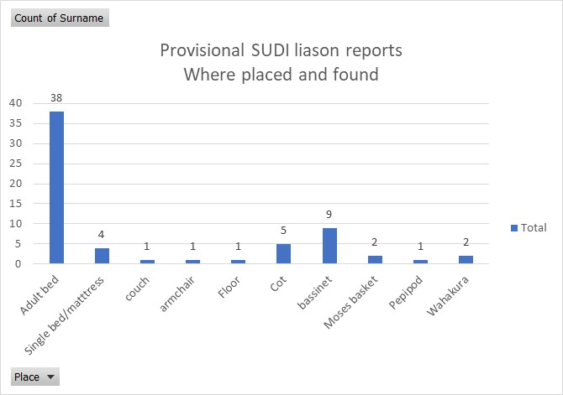

Safe sleep information
Caregivers were asked if they had received information about safe sleep; who had provided the information; how they received the information and what they remembered as the key messages. Only two whānau/families reported not receiving any information. Most of the messages were delivered verbally but with extensive use of brochures and, in some cases, video and/or a physical demonstration. Seventy-five percent of caregivers had good or very good knowledge of key risk factors.

Protective factors
Known protective factors included:
- breastfeeding (82% had some breast feeding, with 43% having any breast milk at time of death)
- dummy use at time of last sleep 14%
- sleep sack use at time of last sleep 5%.

Health practitioners contact in the two weeks before death
Recent medical (hospital, GP or visiting nurse) review (in the two weeks before death) had occurred in 46 of the 64 infants (72%). This suggests there is opportunity for considering extra supports for those infants at high risk – possibly requiring all health providers to be aware of and ask about broader aspects of health when seeing infants with medical symptoms.

Caveat
At the end of each report, a subjective assessment was made as to whether there were any obvious inconsistencies in the report that might raise questions about the accuracy of the information. For 28% of cases, some degree of inconsistency was judged to be present in the report.

Thematic analysis
The data from the provisional SUDI liaison reports were assessed under the themes of:
1. extreme maternal/paternal tiredness (impacting on sleep position / settling / irritable infant)
2. caring for an unwell infant and the impact on sleep place
3. non-parental caregivers
4. sleep environment (house/room overcrowding; housing availability and affordability; swaddling; bed-sharing/co-sleeping; no device / separate sleep space used; impaired decision-making; intoxication and drugs; suffocation)
5. inconsistent and/or unreliable information
6. developmental stage (age and device)
7. maternal mental wellbeing.

Extreme maternal or paternal tiredness
Extreme maternal or paternal tiredness was the most significant theme in the qualitative analysis. Parental exhaustion directly impacted on the infant’s sleep place and position. Extreme tiredness was given as the reason for co-sleeping and falling asleep whilst infant was skin-to-skin, breastfeeding (n=4) or being held in the parent’s arms in 29 of the 64 cases. One specific example of maternal exhaustion was due to midnight prayers as one whānau/family prepared for COVID-19 nationwide alert level 4 restrictions. Considering their high level of understanding and recall of safe sleep messaging, tiredness and lack of sleep is credited with significantly impacting parents’ ability to make rational, safe sleep decisions.

Caring for an unwell infant and the impact of this on sleep place
Having a history of clinical unwellness and/or recent admission to primary or secondary health care was the second most common theme expressed in the reports. Parental decisions to co-sleep or change their infant’s usual sleeping place was due to ‘unwellness’, ‘difficulty breathing’, being ‘unsettled, irritable’ or wanting to ‘watch baby breathe, keep an eye on their breathing’. Co-sleeping in an adult bed was thought to be ‘safer’ for an unwell and/or unsettled infant.
Recent medical assessments for ‘failure to thrive’, slow weight gain and respiratory issues were common, and these impacted significantly on increased bed-sharing/co-sleeping and pillow use.

The use of pillows was another contributory factor associated with an unwell infant, although in some cases, pillows were used during every sleep. If an infant had been unwell, pillows were commonly (n=12) placed under infant’s head, shoulders or body to encourage elevation, comfort, ‘open’ the airway and sleep position support. Tri-pillows were also used to surround the infant as a ‘protective, own’ space and an alternative to using a safe sleep device.

Pre-existing clinical risk factors, such as intrauterine growth restriction (IUGR), inadequate weight gain, prematurity, intrauterine toxic brain impairment, surgical hernia repair and recent secondary health care in-patient admission impacted on the parents’ decisions of where to have the infant sleep. These factors also compounded an already compromised environment and infant, as well as the notable SUDI risk factors. Two infants had been admitted to secondary health care facilities with respiratory conditions two weeks before their death. Symptoms persisted following discharge and parents described their infants as ‘always being unsettled’.

Irritability, frequent crying and ‘being unsettled’ was another common theme apparent across many case reviews. Some parents/foster parents described their infant as being ‘naughty’, ‘attention seeking’ and a ‘grizzly little baby’. One infant was fed 1–2 teaspoons of vegetables at four weeks of age to settle persistent crying.

A whānau/family history of SUDI, either maternal or paternal, was recognised in four cases.

Non-parental caregivers
In five cases, sleep place was determined by a caregiver other than the infant’s parents. This impacted on sleep device availability and, ultimately, choice of sleep place. Grandparents were the most common non-parental caregiver.

Often safe sleep devices, such as a Pēpi-Pod↓ or bassinette, had been used when the infant was younger/smaller. As they grew, a portable safe sleep bed was not as available, which left non-parent caregivers with no other alternative than a couch, armchair or adult bed. For one infant, cultural and language difficulties resulted in a change in their usual sleep place and position from a bassinette to an adult bed.

Sleep environment (not already identified in the quantitative analysis)
An increasingly obvious theme was the influence and subsequent risk of infants’ sleep environment. Several factors impacted on the level of risk:
- house/room overcrowding (housing availability and affordability)
- swaddling
- bed-sharing/co-sleeping (no device / separate sleep space used)
- impaired decision-making (intoxication and drugs)
- suffocation.

The social determinants of health are modifiable factors that had a detrimental and frequent effect on many of these cases. Poverty and housing unaffordability resulted in the whānau/families of most cases living in shared accommodation, boarding, renting and living in one room.

Often overcrowding would be specific to the sleep area (kitchenette, lounge, small bedroom). As a result, a separate infant safe-sleep bed could not fit in the room (because there would be multiple other children and adults sleeping in the same space) and bed-sharing with an adult and another child was common practice. Single mattresses also featured in many cases, which prevented the use of infant sleep safe beds due to confined space, for example, in one instance, because of lack of space a wahakura had to be placed on the floor. In another example, the infant was placed in a bassinette on their side, with a rolled-up blanket to maintain the position. In another, a Pēpi-Pod® mattress was used that was too small for the bassinette, and the gaps were filled with soft toys.

Swaddling occurred in at least seven cases. A Safe T Sleep Sleepwrap® device, bumper pads around the bassinette and a mattress elevated to assist with infant’s breathing were used. One infant was placed in a prone position for every sleep, as this was how the infant had been positioned in the neonatal intensive care unit (NICU). The parents did not recall any safe sleep advice or information about the risks of prone sleeping once home.

Bed-sharing/co-sleeping was a common practice as reflected in the quantitative data. However, an infant safe-sleep bed was often used during the day but not at night, with the infant being in the bed co-sleeping with a parent, as a method of settling to sleep.

Excessive alcohol and/or narcotic consumption by an adult co-sleeping with their infant at the time of death occurred on 10 occasions. In these cases, recall of sleep position, place and length of time was difficult to reliably ascertain. Drug and/or alcohol addiction and whānau/family violence were factors that commonly resulted in household dysfunction and, ultimately, choice of sleep space and position.

Suffocation by an intoxicated adult occurred in three cases. Impaired decision-making may have resulted in at least two newborn SUDI cases, with the infants being left for extended periods of time between the last feed and being checked/found. In these cases, parents reported a time delay of 10–12 hours between last feed and checking, with one of these cases involving an infant who was seven weeks of age.

At least eight SUDI were associated with suffocation, including by bedding, adult’s arms/body, a dog or younger siblings. Several infants were placed prone on an adult’s chest, held in their parent’s arms or breastfeeding at the time of death.

Inconsistent and/or unreliable information
Inconsistent or incomplete data or an inability to recall information resulted in data unreliability in 17 cases. Inconsistent data reporting from either police or SUDI liaison interviewers or impaired information sharing from intoxication/drug consumption were the most common factors given for inconsistent and/or unreliable information.

One parent declined to participate in the interview process, and another set of parents left during the interview and declined to participate further. In both these cases, information was elicited from other whānau/family members as far as possible. In four cases, the case review was inconclusive, requiring a post-mortem examination to confirm SUDI.

Developmental stage (age and safe sleep space)
The most common age of SUDI was under eight weeks. With increasing age and movement, rolling risk increased as an unsafe sleep position change occurred. Three infants crawled and were found in the gap between the adult bed and adjacent wall. One infant was found head down and only feet visible between a lounge couch and single adult bed. In another instance, an older sibling had rolled onto the SUDI infant. At least three infants had outgrown their safe sleep device and an appropriate alternative had not been available. In two cases, safe sleep messages were thought to only apply up to six months of age and, as a result, bed-sharing was assumed to be safe for an older infant. In one instance, it was disclosed that a car seat was a common sleep space (day and night).

Maternal mental wellbeing
Maternal mental wellbeing (with medication being required) was a factor in at least five cases.

Summary
Overall, the findings suggest there are no major changes to the known risk factors for SUDI. Key new learnings from this study include the follow.
- Most of these whānau/families, with a few exceptions, actually have very good knowledge about risk factors for SUDI.
- The majority of parents who smoke lack engagement with smoking cessation support antenatally and postnatally.
- In this group, direct bed sharing was common and often occurred even when safer sleeping spaces, such as wahakura, waikawa, Pēpi-Pods↓ and bassinets, were available in the house (occurring more often at night than in relation to day-time sleeps).
- Direct bed sharing often occurs alongside extreme tiredness of the parents, an infant who is crying, infant illness and/or a lack of appropriate space in the house for the whole whānau/family.
- Financial insecurity and poor housing are significant factors present in many of these whānau/families.

A number of other issues were also identified.
- Winter re-emerged as a peak time for SUDIs.
- The majority of SUDI infants were under three months old (56%), and 39% were under 8 weeks old.
- There was a high representation of especially vulnerable infants (17% were premature births, and 70% involved situations where the mother smoked).
- By ethnicity, 65.6% of SUDIs were Māori and 20.3% were Pacific peoples, with 86% identifying as Māori or Pacific peoples.
- A total of 70% of SUDI mothers smoked, and there was a lack of engagement with smoking cessation programmes, even though such programmes were offered to 74% of smoking mothers.
- Alcohol or other drug use was self-reported by 20% of whānau/families.
- In all, 30% of SUDI infants had been placed in known unsafe sleep positions (side or front) and about half of SUDI infants had been found in an unsafe sleep position (between 45% and 54%).
- A total of 68% of SUDI infants had been placed in an unprotected, potentially dangerous place to sleep (direct adult bed sharing, couch or armchair). Of those directly bed sharing, 67% had a safe sleep alternative available within the home.
- The day sleep space was often safer than the night sleep space.
- Pillows were used for propping up infants or keeping them separate, especially unwell infants.
- Breast feeding took place in 82% of the cases.
- In all, 72% had received a health review in the previous 2 weeks.
- Most parents reported extreme maternal tiredness and the need to have the infant sleep close by for irritability or concerns about the infant.
- The infant’s sleep environment was affected by housing issues and not having appropriate housing.
- Many of the whānau/families expressed concern for the mother’s mental wellbeing.
- Non-parent caregiving or unusual changes, for example, going on holiday were seen as a factor.
- Older infants who were capable of crawling could easily move into an unsafe space, for example, crawl into and become jammed between a mattress and the wall.

Recommendations
The recommendations are grouped in categories, starting with recommendations about caring for the infants and moving through to recommendations for health practitioners, funders and finally the whole of government. While each category is labelled as being directed to a specific group, the previous category’s recommendations should be considered alongside the more specific recommendations.

Recommendations for immediate action are coloured red. These are actions or approaches that can be integrated in current programmes of work. In many instances, the recommendation can best be achieved by collaboration between all parts of the health care system.

For every infant
Recommendation | Why this recommendation | Further comment
Avoid all types of smoke. | Of infants that died, 70% were exposed to tobacco smoke. | Second-hand smoke injures a person’s lungs and makes it harder for them to breath.
Have the infant sleep with their face always clear (not covered by blankets, mattress, sheets, arms or adult bodies or breasts). | Over 50% of infants reviewed did not have their face clear when found. | Anything hard or soft covering an infants face can make breathing difficult or force the infant to re-breath their own breath. This would normally wake an infant, but under a certain age and in some babies, it does not.
Have the infant sleep on their back. | Of the infants that died, 30% were placed for sleep on their side or front, and about half of the infants were found dead on their side or front. | Infants sleeping on their front find it harder to respond to a stress and are much more likely to lift their head and put their face down into a soft surface where they re-breath their own breath.
Have the infant sleep on a flat surface. | Many infants that died were placed for sleep on cushions, pillows or propped up. | A flat surface makes it harder for the infant to slip underneath bedding. The Consumer Product Safety Commission in USA recently banned any cot or in-bed device with an angle of more than 10 degrees.
Enjoy breastfeeding. | Of the infants that died, 82% had some breast feeding. | Breastfed infants have been found to have stronger immune systems.

For parents
(note also the recommendations above)
Recommendation | Why this recommendation | Further comment
Make a plan with your midwife, partner or whānau/family about where your infant will sleep when you are exhausted. | You have a good understanding of the risks for your infant, but putting that knowledge into action can be hard when you are very tired.
If you smoke in pregnancy, find the best support in your area to help you stop. | Over 70% of infants that died had a parent who smoked. | Talk to your partner, whānau/family, iwi, midwife or GP or contact the Quitline on 0800 778 778 for help with stopping smoking.
Even when you infant cries a lot or appears unwell, it is safest for them to sleep in their own space with their face clear.
Being exhausted or taking drugs (alcohol or sedatives) makes it harder to hear and respond to your infant when they need you.
Ask for help when you get really tired. |  | Ask your whānau/family, WCTO service or contact the Whānau Āwhina Plunket’s free helpline PlunketLine, 0800 933 922.

For the wider whānau/family
(note also the recommendations above)
Recommendation | Why this recommendation | Further comment
Look out for tired mothers and help them out. | The majority of mothers are really tired and need more support. | Making good decisions is difficult if you are tired and have a crying or sick infant.
Support mothers and fathers when they attempt to decrease their smoking. | Among SUDI whānau/families, 70% of mothers were smokers. | Addiction to nicotine is powerful, and most people make many attempts to stop before they succeed.
Check on the infant often and make sure their face is always clear and never covered.

For health care providers (maternity, WCTO providers and child health practitioners)
(note also all the recommendations above)
Recommendation | Why this recommendation | Further comment
Support mothers who smoke in pregnancy. Where the mother declines smoking cessation support, focus on how to make the infant’s sleeping environment safer for the next six months. | In this research, most mothers of SUDI infants were smokers who declined smoking cessation support. | Partnership with mothers is crucial at the early stages of an infant’s life, and no judgement is needed: a culturally appropriate engagement is likely to be more successful. The combination of direct bed sharing and smoking is the danger, and where smoking has been taking place throughout the pregnancy, there needs to be ongoing support to ensure the infant has a safer sleep environment for at least six months.
Modify messaging about risk factors to make it mana enhancing and promoting partnerships.  Develop resources to support the mother and other whānau/family members when the infant is crying and unsettled and the mother is exhausted. | Infants are sometimes taken into the parental bed when they will not settle elsewhere or parents want to keep a close eye on them because of concerns about their health. Tired breastfeeding mothers also sometimes fall asleep while breast feeding.
Ensure safe sleep is considered following assessment (or a visit to a primary or secondary paediatric service) and appropriate messages are provided.

For DHBs and organisers of health care delivery
(note also all the recommendations above)
Recommendation | Why this recommendation | Further comment
Fund and implement smoking cessation programmes that are effective for Māori. | In this research, 86% of whānau/families with SUDI infants were Māori or Pacific peoples and the 76% were smokers.
Fund hapū wānanga models as the best-practice evidence-based model to deliver antenatal messages and education for whānau Māori. | Current opinion is that this model engages and maintains engagement and support for whānau Māori better than mainstream services.
Support stakeholders to direct resources to reduce SUDI inequity for Māori and Pacific communities, including extra effort to engage and maintain whānau/family support for at least six months after an infant is born. | This research has shown that 86% of the affected whānau/families are Māori or Pacific peoples.
Upscale existing models that are working well for Māori and/or Pacific whānau/families and implement these models in other areas (for example, MidCentral DHB Mokopuna Ora funding). | See above.
Use the provision of a safer sleep space (wahakura waikawa and Pēpi-Pods®) as an educational and ongoing engagement tool. | Non-use of safer sleep spaces, with continued direct bed sharing, can increase the risks for infant. This research has shown that 62% of infants died in an adult bed direct bed sharing situation.  Of these SUDI infants, 67% had a safer alternative place to sleep (either a cot (4), bassinet (16), Moses basket (2), Pēpi-Pods® (13) wahakura (4) or waikawa (1) in the home.

For Ministry of Health (maternity programme, WCTO programme and tobacco control group)
(note also all the recommendations above)
Recommendation | Why this recommendation | Further comment
Strengthen effective smoking cessation programmes for Māori by Māori in pregnancy and post-natal period. | In this research, most whānau/families had a parent who smoked. | Of these whānau/families, 71% refused support around smoking cessation so engagement is the critical issue.
Increase integration of maternity, WCTO and smoking cessation teams to produce synergistic funding programmes. | Multiple programmes that do not present a unified presence to whānau increase their resistance to engagement.
Develop a nationally consistent and equitable post-SUDI support pathway; including grief/trauma counselling. | There appeared to be inconsistent and often absent support for whānau/families after the death of their infant.
Review maternal mental wellbeing funding and resource allocation, particularly cross-agency partnership with Family Start, WCTO enhanced support pilots, WCTO redesign and the Ministry’s maternity group.
Integrate and fund the SUDI prevention programme under one umbrella, with a governance group that includes consumers, providers, and the maternity, WCTO and tobacco control group within the Ministry.
Have the national SUDI programme, working in collaboration with the Ministry and other agencies, deliver a national campaign on SUDI prevention. The messaging should resonate with Māori and Pacific whānau/families in particular, using multiple communication methods including social media channels. | Some factors, such as infant sleep position, need ongoing reinforcement. The focus should be on community and whānau/family supporting mothers who get very tired, which makes it hard for them to make good decisions about safe practices for their sleeping infant.
Regularly analyse data provided by DHBs on who is getting safer sleep devices. | Currently, there appears to be no analysis of DHB data on who gets safer sleep beds.
The Ministry’s Chief Advisor on Child and Youth Health should meet at least annually with the coroners to discuss data flow from the coronial system to the Ministry’s Mortality Collection (MORT). | Currently only ad hoc meetings are held, and for the current dataset held at Ministry, SUDI liaison reports were only available for 72% of SUDI deaths in the review period.
Ask the Health Quality and Safety Commission (HQSC) to review and report annually on SUDI deaths and preventable factors by analysing data collected from perinatal and child and youth mortality review committees. | The last full report on SUDI deaths was in June 2017, reporting deaths to 2015. This is not rapid enough to inform prevention efforts. The HQSC annual summary reports deaths up to two years earlier. | In the last year, the Ministry has passed on SUDI liaison reports it received from the coronial system to the Perinatal and Maternal Mortality Review Committee and CYMRC, so more rapid reporting should be possible.
Review the WCTO enhanced support pilot programme data, specifically SUDI and maternal mental health outcomes, to determine if an intensive, strengths-based, whānau/family-led model of care is a protective measure for SUDI risk factors.

For researchers and research funding agencies
(note also all the recommendations above)
Recommendation | Why this recommendation | Further comment
When and why do whānau/families who have been given a safer sleep bed stop using that bed?
Does our public health programme giving safer sleep spaces to high risk whānau/families increase the risk of direct bed sharing when those whānau/families stop using the safer sleep spaces?
What are the safest options for safe sleeping for infants who have outgrown the wahakura or Pēpi-Pods®?

For other ministries (education, social development, housing)
Recommendation | Why this recommendation | Further comment
Ministry of Social Development, Ministry of Housing and Urban Development: Higher-risk pregnant mothers and infants should be high on the social housing priority list for warm and uncrowded housing.
Ministry of Education: Include principles of a good and safe sleep into the New Zealand Child and Youth Wellbeing Strategy.

For Government
Recommendation | Why this recommendation | Further comment
Poverty reduction that is especially focused on hapū Māori and whānau with infants would help reduce inequitable SUDI rates. | Underpinning most of these SUDI deaths is poverty. About half the whānau/families reviewed had no or extremely limited financial resources and poor and crowded housing: an important element in where infant sleeps. | Appendix 2: Causal pathways to SUDI risk factors and preventing SUDI shows a diagram of key drivers.

References
Cowan S, Bennett S, Clarke J, et al. 2013. An evaluation of portable sleeping spaces for babies following the Christchurch earthquake of February 2011. Journal of Paediatrics and Child Health; 49(5): 364–8.
Mitchell EA, Scragg R, Stewart AW, et al. 1991. Results from the first year of the New Zealand cot death study [see comments]. The New Zealand Medical Journal;104(906): 71–6.
Mitchell EA, Ford RP, Taylor BJ, et al. 1992a. Further evidence supporting a causal relationship between prone sleeping position and SIDS. Journal of Paediatrics and Child Health; 28(1): S9–12.
Mitchell EA, Hassall IB, Scragg R, et al. 1992b. The New Zealand Cot Death Study: Some legal and ethical issues. Journal of Paediatrics and Child Health; 28(1): S17–20.
Mitchell EA, Taylor BJ, Ford RP, et al. 1992c. Four modifiable and other major risk factors for cot death: the New Zealand study. Journal of Paediatrics and Child Health; 28 Suppl 1:S3–8.
Mitchell EA, Thompson JM, Stewart AW, et al. 1992d. Postnatal depression and SIDS: a prospective study. Journal of Paediatrics and Child Health; 28(1): S13–6.
Mitchell EA, Ford RP, Stewart AW, et al. 1993. Smoking and the sudden infant death syndrome. Pediatrics;91 (5): 893–6.
Mitchell EA, Tuohy PG, Brunt JM, et al. 1997. Risk factors for sudden infant death syndrome following the prevention campaign in New Zealand: a prospective study. Pediatrics;100(5): 835–40.
Mitchell EA, Thompson JM, Zuccollo J, et al. 2017. The combination of bed sharing and maternal smoking leads to a greatly increased risk of sudden unexpected death in infancy: the New Zealand SUDI Nationwide Case Control Study. The New Zealand Medical Journal; 130(1456): 52–64.
Scragg R, Mitchell EA, Taylor BJ, et al. 1993. Bed sharing, smoking, and alcohol in the sudden infant death syndrome. New Zealand Cot Death Study Group [see comments]. BMJ; 307(6915): 1,312–18.
Taylor BJ. 1991. A review of epidemiological studies of sudden infant death syndrome in southern New Zealand. Journal of Paediatrics and Child Health; 27(6): 344–8.
Taylor BJ, et al. 2015. "International comparison of sudden unexpected death in infancy rates using a newly proposed set of cause-of-death codes." Arch Dis Child 100(11): 1018-1023.
Tipene-Leach D, Abel S. 2010.The wahakura and the safe sleeping environment. Journal of Primary Health Care;2(1): 81.

Appendix 1: SUDI liaison form v2.1

SUDI Liaison Report
CSU-
Version: Draft/Final
Last edited: DD/MM/YY

- Identifying Data
  - Name/s of person interviewed:

Relationship to baby:

Contact Details:
Street
Suburb
Town/City
Mobile
Landline
Email

  - Baby’s family name/s (and any other surnames the baby may have)

  - Baby’s first name/s

  - What did you call the baby?

  - Baby’s sex

  - Baby’s date of birth

  - Baby’s age at death

  - Baby’s ethnicity/ies (tick all that apply)
Māori – Iwi: NZ European
Samoan Cook Island Māori Chinese
Indian Tongan Niuean
Other – Specify:

  - Baby’s usual home address
Street
Suburb
Town/City

  - Address where baby died
Street
Suburb
Town/City

  - Mother’s name

  - Mother’s previous or other name/s

  - Mother’s ethnicity/ies (tick all that apply)
Māori – Iwi: NZ European
Samoan Cook Island Māori Chinese
Indian Tongan Niuean
Other – Specify:

  - Mother’s date of birth

Mother’s age

  - Mother’s address
Street
Suburb
Town/City

  - Mother’s contact/s
Mobile
Landline
Email
  - Father’s name

  - Father’s ethnicity/ies (tick all that apply)
Māori – Iwi: NZ European
Samoan Cook Island Māori Chinese
Indian Tongan Niuean
Other – Specify:

  - Father’s date of birth

Father’s age

  - Father’s address
Street
Suburb
Town/City

  - Father’s contact/s
Mobile
Landline
Email

  - Name of person/s looking after baby at the time of death

Their relationship to baby

  - Address (if different from above)
Street
Suburb
Town/City

  - Contact/s (if different from above)
Mobile
Landline
Email

- Obstetric History

  - Baby’s place of birth
Name of hospital, or address if at home

  - Compared to EDD (Expected Date of Delivery) was the baby born on time, early or late?
On time
Early weeks early:
Late weeks late:

  - Was the baby a singleton, twin, triplet, quad or higher?
Singleton Twin Triplet Quad or higher

  - Birth weight (grams)

  - Were there any complications during pregnancy, delivery or at birth?
e.g. C section, baby needed oxygen etc.

Details from those who were there

  - Events and timeline leading up to the time the baby was found unresponsive, including from when baby was put to bed and/or last seen alive. Obtain accounts from all involved, identify who said what and capture any movement of baby from one sleep surface to another.

Suggested phrases/openings, for example:
“Just thinking back to Day/Date (i.e. the 8-10 hours leading up to baby being found unresponsive), was it a normal day for you and baby? What was happening that day/afternoon/evening?”

Events leading up to last sleep and details when baby found:

Genogram with infant and significant others: (picture here)

  - Was there anything unusual or different about the baby in the last 24 hours?
No Yes Don’t know

If yes, please describe:

- Time and Place of Death

  - When was the baby placed for this sleep?

If not known give a range between:

  - What date was it?

  - Name of person who placed the baby down to sleep (the LAST sleep) and their relationship to baby

  - Body position when the baby was last placed
On back On front On side Don’t know/unsure

  - Face position when last placed
Face up Face down Face to the side
Don’t know/unsure

  - Position of head and neck in relation to the baby’s body when placed to sleep
Head bent forward Neck straight
Head tipped back Don’t know/unsure

  - When was the baby last seen/heard alive (if approx. time known)?

If not known give a range between:

  - What date was it?

  - How did you know the baby was alive? (for example, was the baby sleeping, crying, lying awake, had the baby just had a feed, warm, had you felt the baby breathing, etc)

  - Face position when last seen alive
Face up Face down Face to the side
Don’t know/unsure

  - When was the baby found unresponsive (if approx. time known)?

If not known give a range between:

  - What date was it?

  - Where was the baby found unresponsive?
Cot Car seat Pēpi-Pod®
Portable cot Swing/Jolly Jumper® Floor
Bassinet Stroller sitting position Change table
Sofa/couch/armchair Stroller lying position Mattress on floor
Bed Bouncinette/baby seat Bean bag
Waterbed Airbed Wahakura
Don’t know
Other – specify:

  - Body position when found
On back On front On side Don’t know/unsure

  - Face position when found
Face up Face down Face to the side
Don’t know/unsure

  - Position of head and neck in relation to the baby’s body when found
Head bent forward Neck straight
Head tipped back Don’t know/unsure

  - When found, had baby moved from where he/she was placed to sleep?
No Yes
If yes, please describe (e.g. lying straight, lying perpendicular)

  - Did the baby appear to be jammed, wedged, trapped or unable to move?
No Yes
If yes, please describe

  - What did the baby feel like when found? (tick all that apply)
Warm to touch Cool to touch Sweaty
Flexible Limp Rigid
Stiff Don’t know/unsure Other
If other, please describe

  - Did anyone try to resuscitate the baby?
No Yes
If yes, who?

What was done? e.g. breaths or compressions or breaths AND compressions

  - Did you notice any blood on the baby, or on the baby’s clothing, sheets, etc?
No Yes Don’t know
If yes, please describe:

  - Did you notice any vomit on the baby, or on the baby’s clothing, sheets, etc?
No Yes Don’t know
If yes, please describe:

- Questions about usual sleep

  - Where was the usual bed or sleeping surface for the baby?
- During the day

- During the night

  - What was the baby’s usual sleeping position?
On back On front On side
It varies Don’t know Other
If other, please describe:

- Questions about baby’s clothing and the general environment

  - Was the baby placed to sleep with a dummy?
No Yes Don’t know

  - How often did the baby use a dummy?
Never Often Don’t know
Seldom (less than once a week)

  - What kind of clothing was the baby wearing – list all items of clothing, including details like fabric, thickness, weight, sleeves etc.
(for example, sleeveless, cotton, vest, towelling, Stretch & Grow (long sleeves and legs, no feet), cotton socks, acrylic cardigan, cotton beanie, or woollen had, zipped up infant sleep sack. Start with clothing closest to baby’s skin)

  - What was the temperature in the room when the baby was found?
Hot Cold Normal

  - Was any heating or cooling being used in the room where baby was found? (This question relates to the temperature of the room.)
No Yes Don’t know
If yes, please describe (for example, electric heater, gas fire, heat pump):

  - Were there any open windows, open doors or ventilation in use? (This question relates to the ventilation of the room.)
No Yes Don’t know
If yes, please describe (for example, fan):

- Questions about the bed, couch or place the baby was found unresponsive
Please identify the location which best describes where the baby was found
- In a baby bed (cot/bassinette/PP/wahakura) place designed specifically for a baby to sleep)
No Yes
If yes, please go to section 7A

- In an adult bed/mattress
No Yes
If yes, please go to section 7B

- On a couch, car seat, or other place
No Yes
If yes, please go to section 7C

7A. IN A BABY BED
for example, COT / BASSINETTE / MOSES BASKET / WAHAKURA / PĒPI-POD® / PLACE DESIGNED SPECIFICALLY FOR A BABY TO SLEEP

7A.1. What type of bed was being used
Please also specify brand and model, if known

7A.2. Was the bed in the parents’ room
No Yes Don’t know Other
If other, please describe:

7A.3. Was the baby’s bed placed on the same surface as another person, or people?
No Yes Don’t know

7A.4. Was the baby’s bed placed on a level (flat) surface?
No Yes Don’t know
If no, please describe:

7A.5. Were any pillows (or anything like a pillow) being used under the baby’s head?
No Yes Don’t know Other
If yes, how many?
Please describe (type of pillow, filling, cover, brand/model if known etc)

7A.6. What kind of mattress was the baby sleeping on?
Please describe (foam/innersprung, age, condition, softness/hardness, thickness, for example, recently purchased firm 100-mm-thick foam cot mattress with plastic cover, or second hand)

7A.7. How well does the mattress (or similar) fit the sleep space?
Firm at ends and sides Loose fit
Loose fit with gaps filled in (for example, with material)
Don’t know Other
If other, please describe:

7A.8. What layers were UNDER the baby (between the mattress and the baby)?
Please describe fabric: for example, polythene sheet, cotton mattress cover and polyester sheet (was it fitted, untucked etc.), soft duvet used; include brand/model if known

7A.9. Were there any other layers COVERING the baby?
No Yes Don’t know
If yes, please describe each layer starting from baby and list layers outwards: fabric, thickness, weight:
for example, polyester sheet, light synthetic or double mink blanket folded in two, single layer brushed microfibre blanket or air cell blanket; include brand/model if known

7A.10. Which parts of baby’s body were covered by bedding when baby was PLACED to sleep? (tick all that apply)
Arms Legs Torso Head (scalp)
Face Completely uncovered Don’t know

7A.11. Which parts of baby’s body were covered by bedding when baby was FOUND unresponsive? (tick all that apply)
Arms Legs Torso Head (scalp)
Face Completely uncovered Don’t know

7A.12. Was anything being used to hold the baby in position?
(for example, head wedge, Safe-T-Sleep®, pillow, rolled up towel or similar, etc)
No Yes Don’t know
If yes, please describe

7A.13. Was baby swaddled or wrapped tightly?
No Yes Don’t know

If yes, please describe material used to swaddle baby
for example, muslin, rolled-up nappy, towel etc

7A.14. Was anything covering baby’s whole head, mouth or nose when found unresponsive
for example, bumper pads, pillows, soft toys?
No Yes Don’t know
If yes, please describe

7A.15. Was anyone in the same room when the baby died? (not bed sharing)
No Yes
Adults (over 18 years) How many?
Child (under 18 years) How many?

7B. BABY FOUND IN AN ADULT BED/MATTRESS

7B.1. Indicate whether it was bed or a mattress on floor (or other), mattress size (single, double/queen, king) and whether more than one bed/mattress was pushed together.

7B.2. Was the bed/mattress pushed up against a solid surface, such as a wall or furniture?
No Yes Don’t know
If yes, please describe

7B.3. Were any pillows (or anything like a pillow) being used under the baby’s head?
No Yes Don’t know Other
If yes, how many? Please describe (type of pillow, filling, cover etc.)

7B.4. Were there other pillows (or anything like a pillow) in the bed?
No Yes Don’t know
If yes, how many? Please describe (type of pillow, filling, cover etc.)

7B.5. What kind of mattress was the baby sleeping on?
Please describe foam/innersprung, age, softness/hardness, thickness, cover:
for example, old, firm innersprung mattress or new couch, soft, synthetic fabric cover

7B.6. What layers were UNDER the baby (between the mattress and the baby)?
Please describe fabric:
for example, polythene sheet, cotton mattress cover and polyester sheet (was it fitted, untucked etc.), soft duvet used

7B.7. Were there any other layers COVERING the baby?
No Yes Don’t know
If yes, please describe each layer starting from baby and list layers outwards: fabric, thickness, weight:
for example, polyester sheet, light synthetic or double mink blanket folded in two, single layer brushed microfibre blanket or air cell blanket

7B.8. Which parts of baby’s body were covered by bedding when baby was PLACED to sleep? (tick all that apply)
Arms Legs Torso Head (scalp)
Face Completely uncovered Don’t know

7B.9. Which parts of baby’s body were covered by bedding when baby was FOUND unresponsive? (tick all that apply)
Arms Legs Torso Head (scalp)
Face Completely uncovered Don’t know

7B.10. Was anything being used to hold the baby in position?
(for example, head wedge, Safe-T-Sleep®, pillow, rolled up towel or similar, etc)
No Yes Don’t know
If yes, please describe

7B.11. Was baby swaddled or wrapped tightly?
No Yes Don’t know
If yes, please describe material used to swaddle baby
for example, muslin, rolled-up nappy, towel etc

7B.12. Was anything covering baby’s whole head, mouth or nose when found unresponsive
for example, bumper pads, pillows, soft toys?
No Yes Don’t know

If yes, please describe

7B.13. Was anyone in the same room when the baby died? (not bed sharing)
No Yes
Adults (over 18 years) How many?
Child (under 18 years) How many?

7C. BABY FOUND ON A COUCH, CHAIRS PUSHED TOGETHER, CAR SEAT OR OTHER PLACE

7C.1. What sleep space was being used for the baby?
for example, a couch, car seat, capsule etc

7C.2. If baby was in a place with straps, was baby strapped in?
e.g. car seat, capsule, pushchair, bouncinette etc
No Yes Don’t know

7C.3. What kind of surface was the baby sleeping on?
Please describe:
e.g. firm car seat with polyester padded lining or soft cushiony couch with woven upholstery

Not relevant Don’t know
Baby lying on top of adult, so not in contact with surface

7C.4. Was the baby’s sleep space a level (flat) surface?
No Yes Don’t know
If no, please describe

7C.5. Were any pillows (or anything like a pillow) being used under the baby’s head?
No Yes Don’t know Other
If yes, how many? Please describe (type of pillow, filling, cover etc.)

7C.6. What layers were under the baby?
e.g. fluffy sheepskin, mink blanket, towel, none

7C.7. Were there any other layers COVERING the baby?
No Yes Don’t know
If yes, please describe each layer starting from baby and list layers outwards: fabric, thickness, weight:
e.g. polyester sheet, light synthetic or double mink blanket folded in two, single layer brushed microfibre blanket or air cell blanket

7C.8. Which parts of baby’s body were covered by bedding when baby was PLACED to sleep? (tick all that apply)
Arms Legs Torso Head (scalp)
Face Completely uncovered Don’t know

7C.9. Which parts of baby’s body were covered by bedding when baby was FOUND unresponsive? (tick all that apply)
Arms Legs Torso Head (scalp)
Face Completely uncovered Don’t know

7C.10. Was anything being used to hold the baby in position?
(e.g. head wedge, Safe-T-Sleep®, pillow, rolled up towel or similar, etc)
No Yes Don’t know
If yes, please describe

7C.11. Was baby swaddled or wrapped tightly?
No Yes Don’t know
If yes, please describe material used to swaddle baby
e.g. muslin, rolled-up nappy, towel etc

7C.12. Was anything covering baby’s whole head, mouth or nose when found unresponsive
e.g. bumper pads, pillows, soft toys?
No Yes Don’t know
If yes, please describe

7C.13. Was anyone in the same room when the baby died? (not bed sharing)
No Yes
Adults (over 18 years) How many?
Child (under 18 years) How many?

- Questions about people who were caring and/or bed-sharing with the baby

  - Was anyone sleeping with or alongside the baby (on the same sleep surface) at any time since the baby was last placed to sleep?
No Yes Don’t know
If yes, how many people?
Number of people:

  - If it was a bed or mattress, what size was it (or equivalent size)?
Single Double/Queen King
Not applicable

  - How much of the night during baby’s last sleep did the baby share this sleep surface with one or more people?
Less than 2 hours 2–5 hours More than 5 hours
Don’t know

  - Answer the following for each person who was sleeping with or caring for the baby
    - Person 1 name

    - Age

    - Relationship to baby

    - Height (cm)
Weight (kg)

    - Where were they sleeping in relation to baby when baby was PLACED to sleep?
For example, right next to baby, in contact, baby was lying on them; if not bed sharing, enter “Not Applicable”

    - Were they present in bed when baby was FOUND unresponsive?
No Yes Not applicable

    - If No, about how many hours/minutes before the baby was discovered unresponsive did they leave the bed?
Length of time (hours and minutes):
Don’t know Not applicable

    - If yes, were they awake or asleep? (When the baby died)
Awake Asleep Don’t know
Not applicable

    - In the 24 hours before the baby was found, did they take or use:
Tobacco/cigarette smoke? No Yes
Type, amount:
Vaping? No Yes
Type, amount:
Any medication? No Yes
Name of medication, time taken:
Alcohol? No Yes
Type, amount, time taken:
Drugs? No Yes
Type, amount, time taken:

    - Do they have or were they affected by a hearing impairment, epilepsy or extreme tiredness?
No Yes

  - Person 2
    - Person 2 name

    - Age

    - Relationship to baby

    - Height (cm)
Weight (kg)

    - Where were they sleeping in relation to baby when baby was PLACED to sleep?
e.g. right next to baby, in contact, baby was lying on them; if not bed sharing, enter “Not Applicable”

    - Were they present in bed when baby was FOUND unresponsive?
No Yes Not applicable

    - If No, about how many hours/minutes before the baby was discovered unresponsive did they leave the bed?
Length of time (hours and minutes):
Don’t know Not applicable

    - If yes, were they awake or asleep? (When the baby died)
Awake Asleep Don’t know
Not applicable
    - In the 24 hours before the baby was found, did they take or use:
Tobacco/cigarette smoke? No Yes
Type, amount:
Vaping? No Yes
Type, amount:
Any medication? No Yes
Name of medication, time taken:
Alcohol? No Yes
Type, amount, time taken:
Drugs? No Yes
Type, amount, time taken:

    - Do they have or were they affected by a hearing impairment, epilepsy or extreme tiredness?
No Yes

- Bed Sharing Practices (usual and last sleep)
  - In general, how often did someone else sleep in the same bed (or other sleep surface) as the baby?
Never
Occasionally/less than once a week)
Often/usual practice

  - If the baby shared a sleep surface with one or more people occasionally or often, how long was this for, on average?
Less than 2 hours
2–5 hours
More than 5 hours
Don’t know
Not applicable

  - If the baby shared an adult bed (or other sleep surface), occasionally or often with another person or people, what were the reasons? (Tick all that apply)
How we always do it Stop the baby disturbing others
Mum too tired Breast feeding
Can’t afford cot Skin to skin contact
Baby seemed unwell Keep baby warm
Bonding Easier to get baby to settle
Cultural reasons No other bed free
Other – specify

  - If baby was sharing an adult bed (or other sleep surface) with another person or people during the LAST sleep, what was the reason? (tick all that apply)
How we always do it Stop the baby disturbing others
Mum too tired Breast feeding
Can’t afford cot Skin to skin contact
Baby seemed unwell Keep baby warm
Bonding Easier to get baby to settle
Cultural reasons No other bed free
Other – specify

- Details about baby’s home
  - Do you own your home, rent or other?

If baby died at home, how many adults (18 years and older) and children live in the home?
Adults (over 18 years) How many?
Child (under 18 years) How many?
Did not die at home

How many bedrooms are there?

Is this a damp house
e.g. mould growth
No Yes

  - How do you get by / make ends meet? (Before and after baby’s death)

- Scene diagram – diagram of full room where baby found deceased
  - Scene diagram – sketch of scene, including the room where baby was found
Include location of bed(s), position of baby and others in the room, covers/blankets, pillows and other items, doors, windows and furniture

- Additional questions about the pregnancy and delivery

  - Gravida
How many times have you been pregnant, including this baby?

  - Parity
How many babies have you given birth to (greater than 20 weeks)?

  - During the pregnancy, did the mother ever feel anxious or depressed?
No Yes Don’t know
If yes, please describe
e.g. medication and/or treatment

  - Did you have a midwife or someone who looked after you during your pregnancy?
E.g. lead maternity carer (LMC)
No Yes Don’t know
If yes, please provide details
Midwife/LMC name
Organisation
Street
Suburb
Town/city
Telephone
Email

  - How many weeks pregnant were you when you first visited a midwife/LMC?

  - If you didn’t see a midwife/LMC, what was the reason?

  - Did the baby’s (biological) mother smoke during this pregnancy?
No Yes Don’t know
If yes, name/type and approximate amount/how often

Did the baby’s (biological) mother vape during this pregnancy?
No Yes Don’t know
If yes, name/type and approximate amount / how often

  - During pregnancy did the baby’s (biological) mother use any of the following:
Over the counter medicines or herbal remedies?
No Yes
Name, type, reason, amount, how often:

Prescription medicines or medicines for pregnancy?
No Yes
Name, type, reason, amount, how often:

Alcohol?
No Yes
Name, type, amount how often:

Other drugs?
No Yes
Name, type, amount how often:

- Smoking among parents/caregivers and others in the household

  - Did the baby’s mother smoke after baby was born?
No Yes Don’t know
If yes, name/type and approximate amount/how often

  - Did the baby’s mother vape after baby was born?
No Yes Don’t know
If yes, name/type and approximate amount/how often

  - Did the baby’s father smoke after baby was born?
No Yes Don’t know
If yes, name/type and approximate amount/how often

  - Were there any other smokers in the household?
No Yes Don’t know
If yes, please give details

- Baby’s Clinical History

  - Did the baby have any falls or injuries in the last 2 weeks?
No Yes Don’t know
If yes, please describe

  - Did the baby have any illnesses or change in behaviour in the last 2 weeks?
No Yes Don’t know
If yes, please describe

  - In the last 2 weeks, did the baby have any of the following?
(tick all that apply)
Cough Cold/sniffles
Fever Fussiness or excessive crying
Vomiting Diarrhoea
Excess sweating Difficulty breathing
Apnoea (stopped breathing) Weight loss
Poor feeding Seizures
Choking Cyanosis (turned grey/blue)
Sleeping more than usual (lethargy)
If yes, please describe

  - In the last 2 weeks, did the baby receive any medication?
Include home remedies, herbal and over the counter medicines
No Yes Don’t know
If yes, please describe
Name of medication, reason given, date, time (repeat for every medication)

  - At any time in their life, did the baby have:
Allergies
Food/medication etc
No Yes Don’t know

If yes, please give details

Abnormal growth, or weight loss
No Yes Don’t know
If yes, please give details

Apnoea
Turned grey/blue
No Yes Don’t know
If yes, please give details

Seizures
No Yes Don’t know
If yes, please give details

Metabolic disorders
No Yes Don’t know
If yes, please give details

Any abnormalities at birth
No Yes Don’t know
If yes, please give details

  - Had the baby been able to roll?
For example, front to back and/or back to front?
No Yes Don’t know
If yes, please give details

  - When did the baby last see a doctor, nurse or other health care provider?
For example, GP visits, ED visits, hospital admissions, WCC visits
Include name of provider, date of visit, reason and any action taken.
If the baby has had less than two visits to a health care provider, please note this.

Name of provider (1)
Date of visit
Reason of visit
Any action taken

Name of provider (2)
Date of visit
Reason of visit
Any action taken

  - Has anyone else in the household been sick in the last two weeks?
No Yes Don’t know

If yes, please give details

- Baby’s Food

  - Was the baby breastfed?
No Yes
Was baby exclusively breastfed from birth?
i.e. no solids or other liquids including formula or water given
No Yes Don’t know
If not currently breastfed, at what age did breastfeeding stop?

  - When was the baby last fed?
Date, time (24-hour clock):

What was given?

How much?
More than usual Less than usual Usual amount

  - Had the baby ever been fed solids
No Yes
If yes, at what age were solids first given?

- Family/genetic clinical history

  - Have any close family member (aunts, uncles, brothers, sisters, parents, grandparents – blood relatives only) died suddenly in infancy, childhood, teenage or early adult years
No Yes Don’t know

If yes, explain
Include name, age and date of death

  - Experienced epilepsy, seizures or blackouts?
No Yes Don’t know
If yes, explain
Include name and date of birth, if known

  - Had a heart condition under the age of 40??
No Yes Don’t know
If yes, explain
Include name and date of birth, if known

- Health education information received

  - Did the GP/LMC/hospital staff or someone else talk with the mother about safe sleep?
No Yes Don’t know
If yes, who was this?

  - How was this information delivered/in what form?
e.g. verbal, pamphlet, workshop, other etc

What does the mother remember?

  - Had the families been offered a Pēpi-Pod®, wahakura or other safe sleep device?
No Yes

If yes, was one supplied?
No Yes

If yes, what type?
Please specify

  - Was the mother (or any other smokers in the household) offered smoking cessation advice?
No Yes Don’t know
Not applicable
If yes, by whom?

17.4. Which stop smoking aids were used, if any?
e.g. patches, gum, vaping, other

Please describe

- Question for family

  - Describe what could have been done better when (i.e. after) your baby died, or anything extra that could have helped in any way

- Permission from family member to be contacted for evaluation process

  - Is the family member willing to be contacted in the next year to discuss their experience of the investigation and the support they were given in relation to their baby’s death?
Advise that, even if they say yes now, they can change their mind if they are contacted.
No Yes

- Information to make notification, other health professionals etc
Designation | Victim Support
Name
Contact details
Street
Suburb
Town/City
Mobile
Landline
Email
Who notified them
Date/time notified
Designation | Well Child / Tamariki Ora Provider
Name
Contact details
Street
Suburb
Town/City
Mobile
Landline
Email
Who notified them
Date/time notified

Designation | Midwife or other LMC (see section 12)
Name
Contact details
Street
Suburb
Town/City
Mobile
Landline
Email
Who notified them
Date/time notified

Designation | Primary Health Care Provider / Medical Centre
Name
Contact details
Street
Suburb
Town/City
Mobile
Landline
Email
Who notified them
Date/time notified

Designation | Mother’s GP
Name
Contact details
Street
Suburb
Town/City
Mobile
Landline
Email
Who notified them
Date/time notified

Designation | Baby’s GP (if different)
Name
Contact details
Street
Suburb
Town/City
Mobile
Landline
Email
Who notified them
Date/time notified

Designation | Hospital
Name
Contact details
Street
Suburb
Town/City
Mobile
Landline
Email
Who notified them
Date/time notified

Designation | Other – Specify
Name
Contact details
Street
Suburb
Town/City
Mobile
Landline
Email
Who notified them
Date/time notified

- Comments by SUDI Liaison, if applicable

- Form completed by

22.1 | SUDI Liaison
Name
Contact details
Mobile
Landline
Email
Date and time of interview
Date and time form completed

Appendix 2: Causal pathways to SUDI risk factors and preventing SUDI

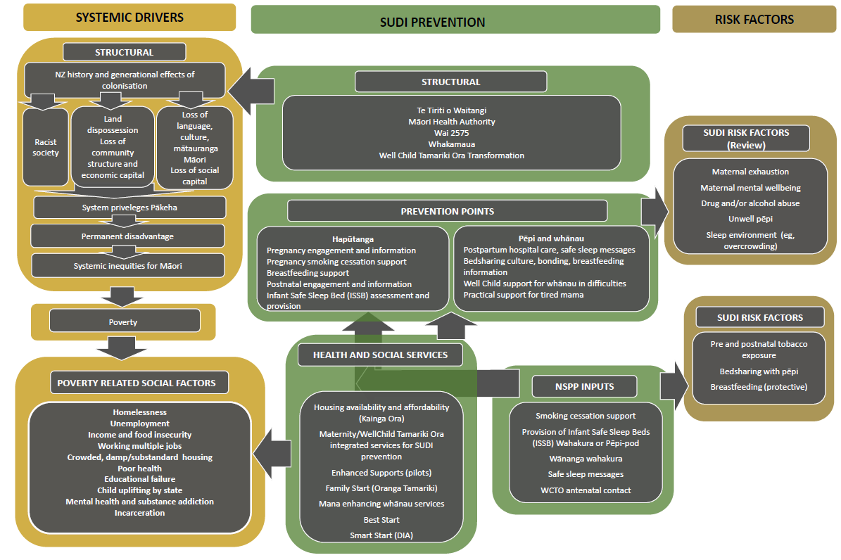

See the webpage Fetal and Infant Deaths 2016 on the Ministry of Health website at: www.health.govt.nz/publication/fetal-and-infant-deaths-2016
For these times, the SIDS rates were probably equivalent to SUDI rates today.
This web tool presents maternity data from the National Maternity Collection and is the latest release in the Maternity and newborn data series. It provides annual health statistics about women giving birth, their pregnancy and childbirth experience and the characteristics of live-born babies in New Zealand between 2009 and 2019. It can be found at: https://minhealthnz.shinyapps.io/report-on-maternity-web-tool/
https://minhealthnz.shinyapps.io/Maternity_report_webtool/
These figures can be found on the Well Child / Tamariki Ora Quality Improvement Framework webpage on the Nationwide Service Framework Library website at: https://nsfl.health.govt.nz/dhb-planning-package/well-child-tamariki-ora-quality-improvement-framework
For more information see, the Consumer Product Safety Commission USA https://www.consumerreports.org/product-safety/cpsc-rule-preventing-sale-of-dangerous-baby-sleep-products-a1191791052/
For more information, see the Well Child / Tamariki Ora services webpage on the Ministry of Health website at: www.health.govt.nz/our-work/life-stages/child-health/well-child-tamariki-ora-services
Family Start is an early home visiting programme focused on children and tamariki. For more information, see the Family Start webpage on the Oranga Tamariki website at: www.orangatamariki.govt.nz/support-for-families/support-programmes/family-start/
For more information on MORT, see the Mortality Collection webpage on the Ministry of Health website at: www.health.govt.nz/nz-health-statistics/national-collections-and-surveys/collections/mortality-collection

